CO03 -

Functionality
The PP Production order is the cost object for carrying production costs for manufacture of Finished product. All costs such as Material consumption, internal activities consumption is collected on the production order. The production order also provides the comparison of the planned cost, target cost and actual cost.

Scenario
You need to see the actual costs collected on the Production order and also compare it with the planned cost.

Requirements
Production order must have materials and activities consumption posted.

Menu Path | Accounting → Controlling → Product Cost Controlling → Cost Object Controlling → Product Cost by Order → Order → PP Production Order → CO03 - Display
Transaction Code | CO03

1. Double Click CO03 - Display

Production Order Display: Initial Screen

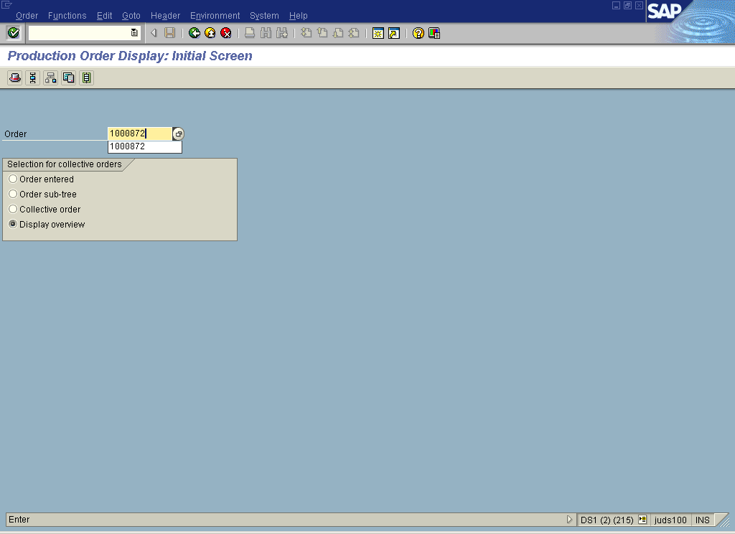

2. Update the following required and optional fields:

Field Name | Description | Values
Order | Number identifying the order | Enter order number  Example: 1000872

3. Click Enter .

Production order Display: Header

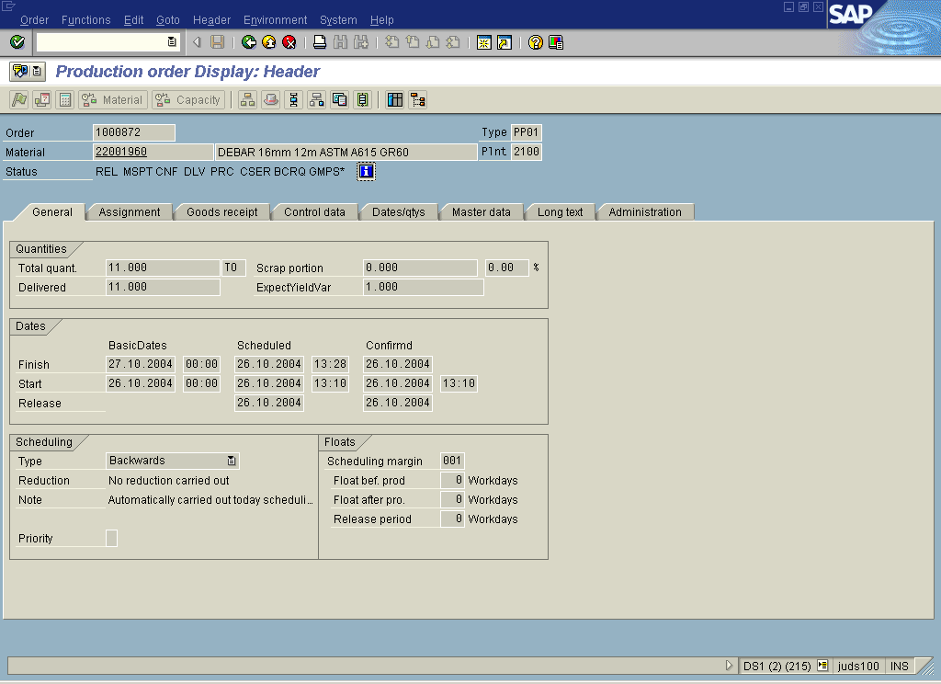

4. Click .

Display Status

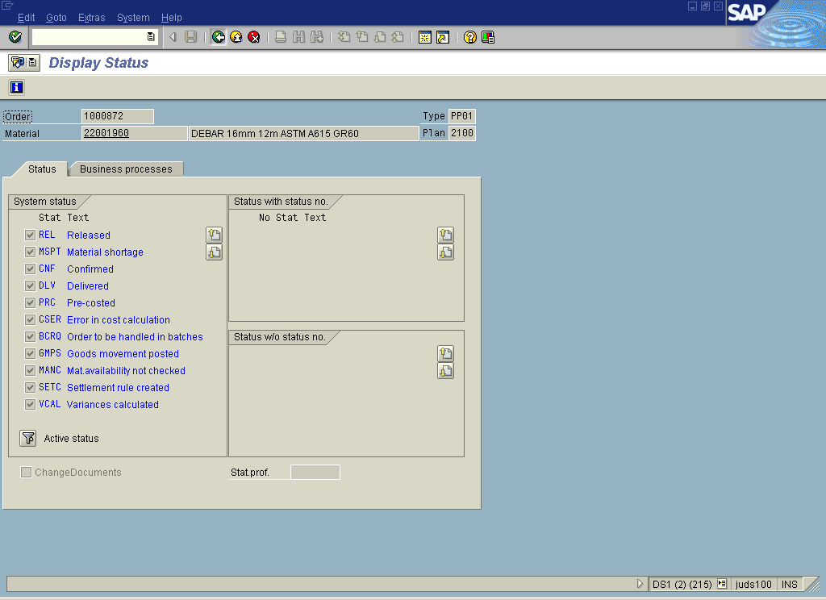

Note: The status of the production order is displayed on the initial screen with abbreviations. The details of the abbreviations and the status of the order can be further known by clicking on the information icon.
5. Click Back

Production order Display: Header

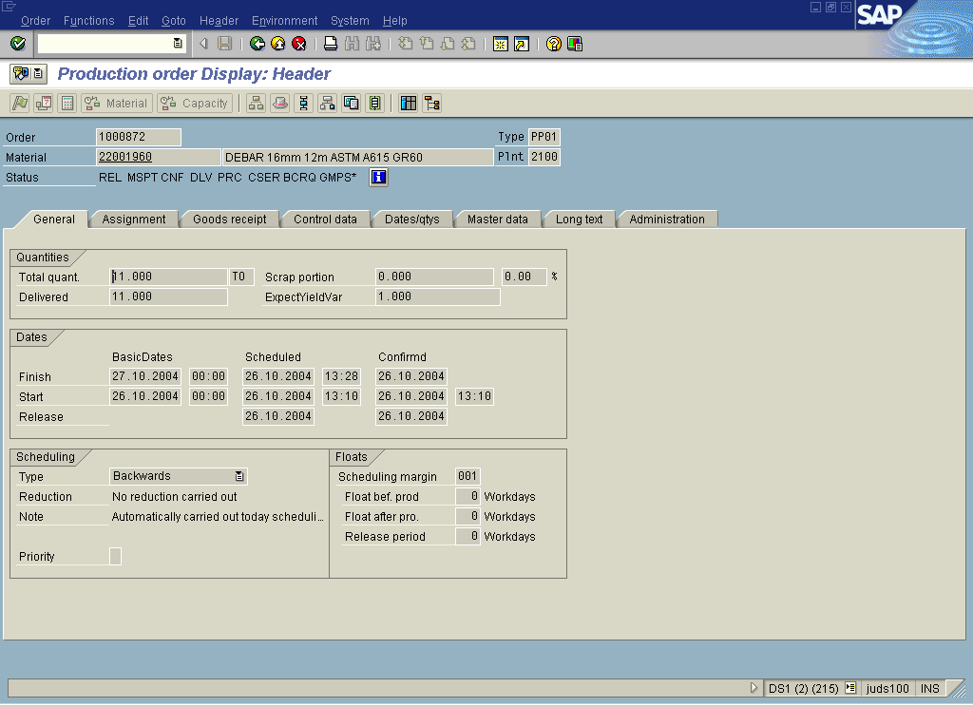

6. Click <tab button> Control data .

Production order Display: Header

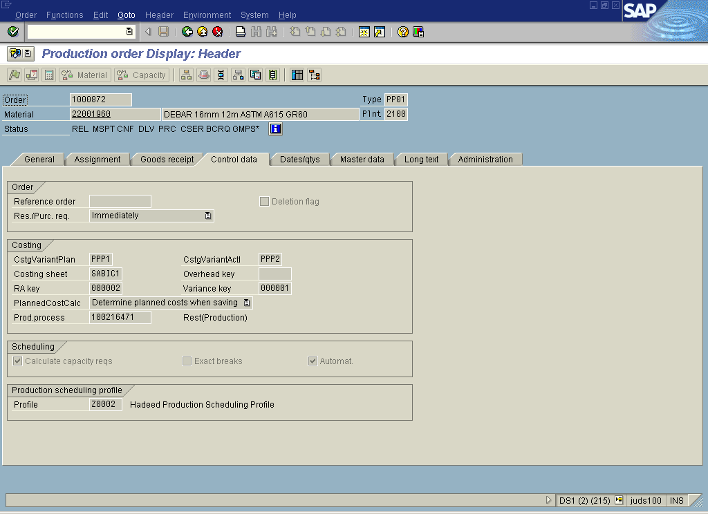

7. Select GotoAnalysis.

Target/actual comparison

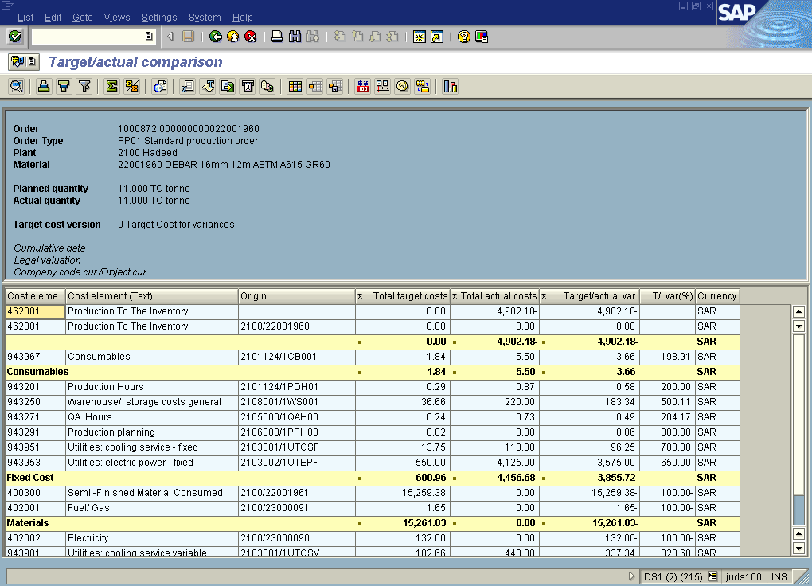

8. Click Back

Production order Display: Header

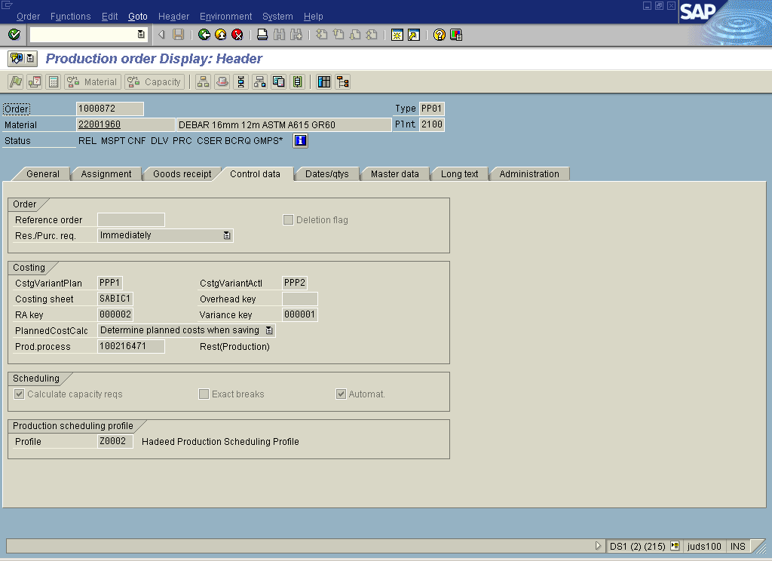

9. Select GotoCostsItemization

Information

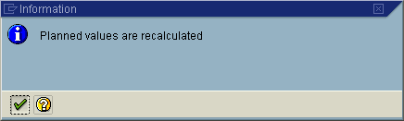

10. Click Continue

Information

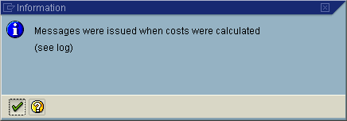

11. Click Continue

Display itemization

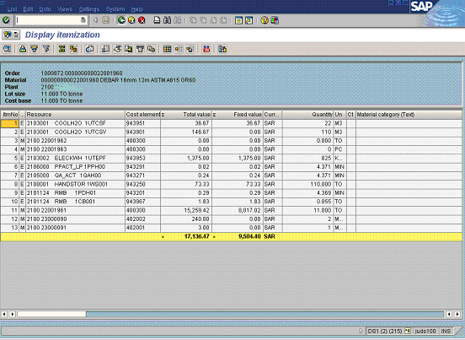

12. Click Back

Production order Display: Header

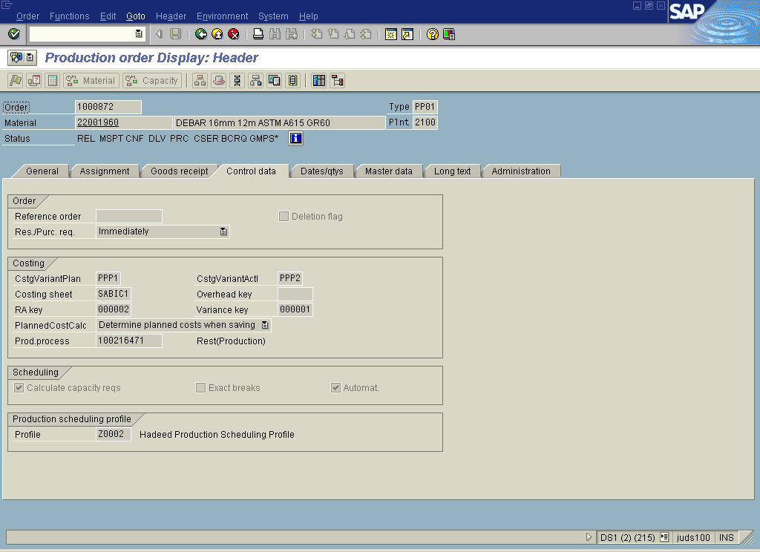

13. Select GotoCost comp. structure

Information

14. Click Continue

Production order Display: Header

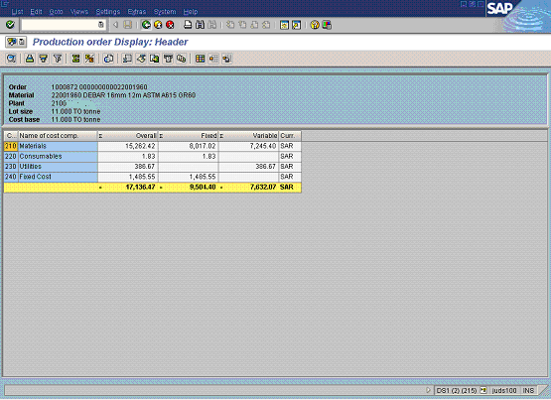

15. Click Back

16. Select GotoCostsBalance

Cost Balance

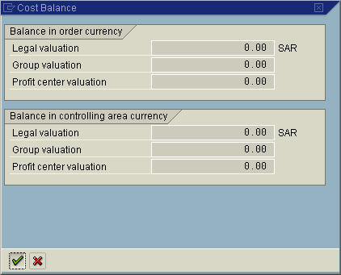

17. Click Continue

Production order Display: Header

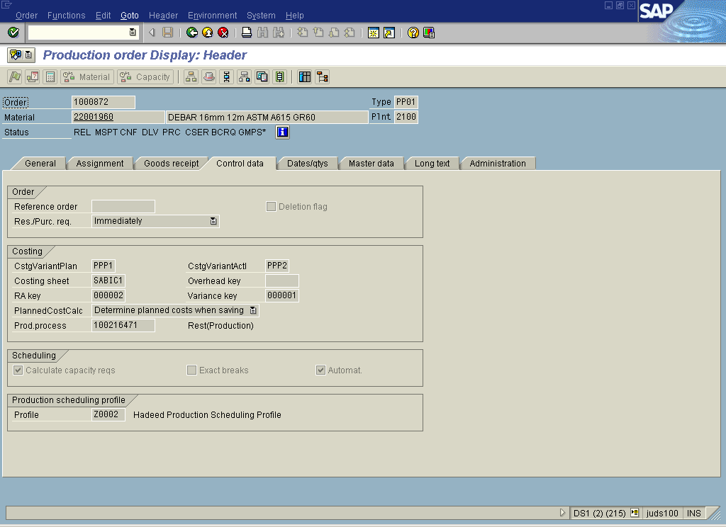

18. Select GotoDocumented goods movements

Order Information System: Detail List of Documented Goods Movements

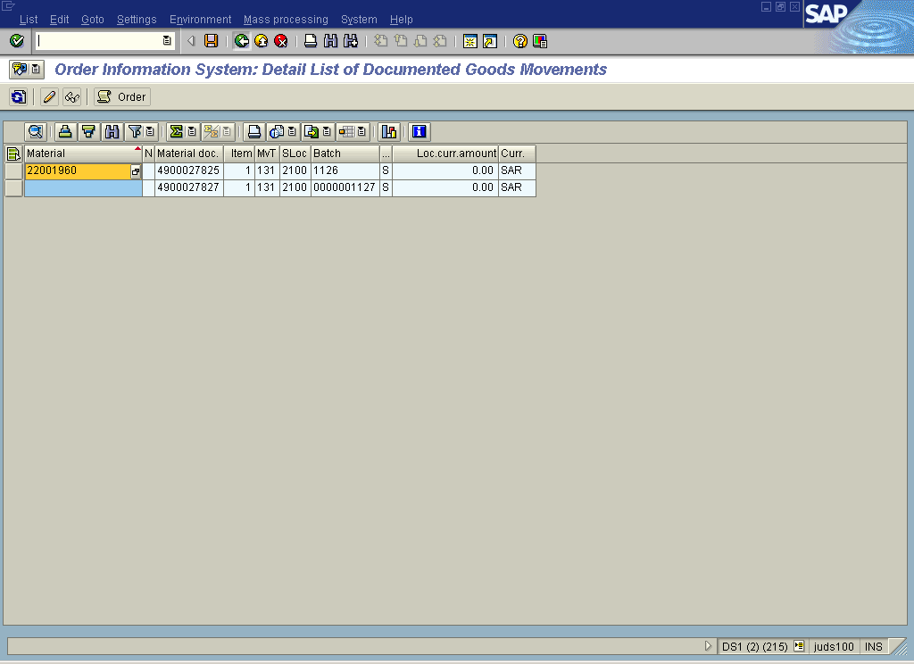

19. Click Back

Production order Display: Header

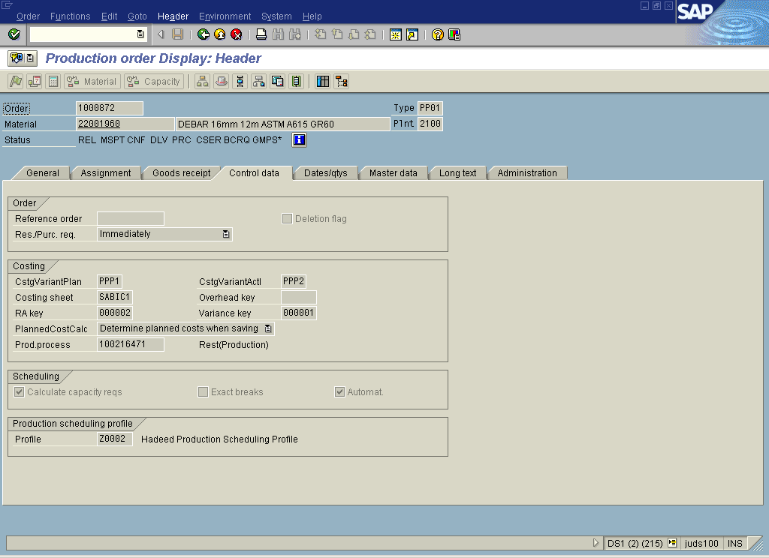

20. Select HeaderSettlement rule

Display Settlement Rule: Overview

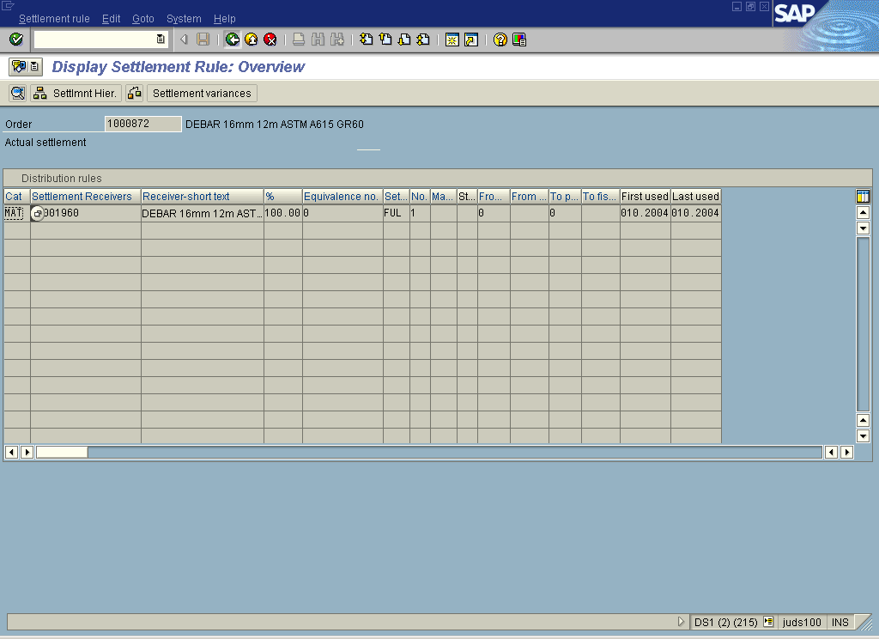

21. Click Back

Production order Display: Header

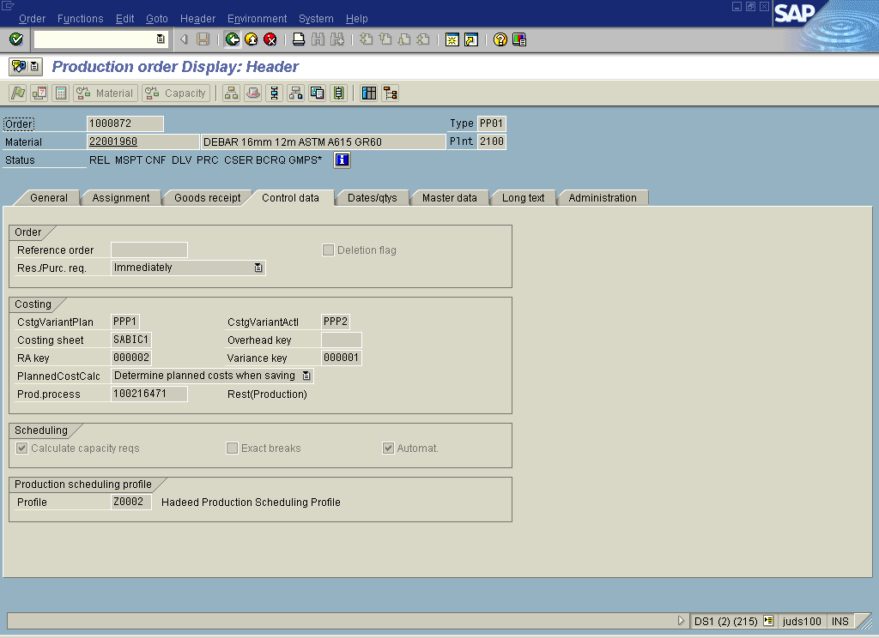

22. Click Back

Production Order Display: Initial Screen

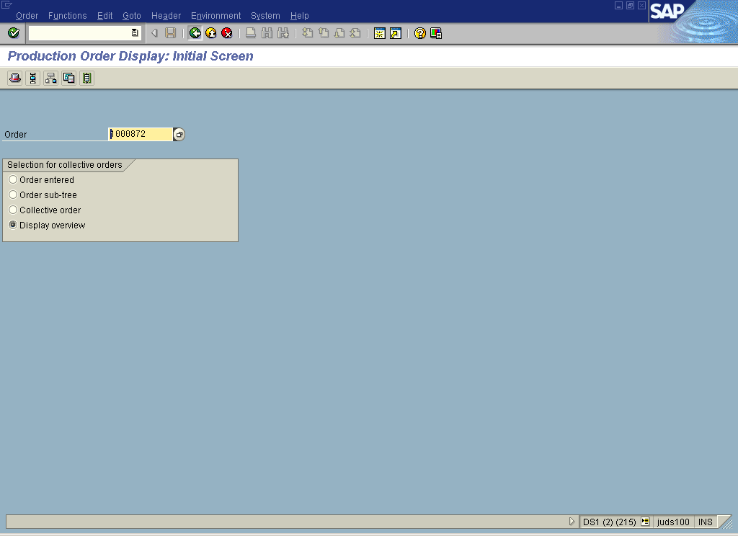

23. Click Back

